MAVUNOLAB Solar Dryer: Control System Assembly Manual
This manual provides instructions for assembling the automated sensing and control system designed to maintain dryer temperatures within of a desired setpoint.

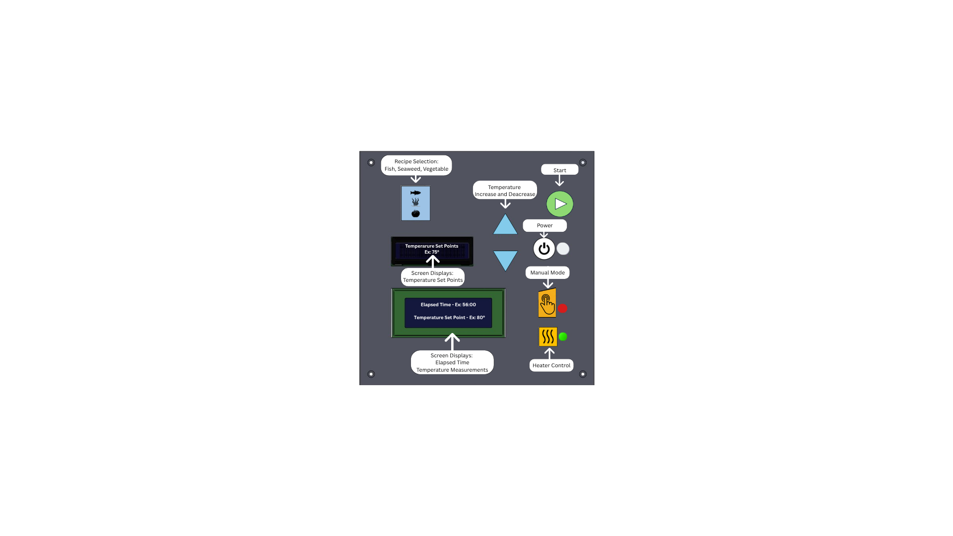
Figure 1 - Diagram of Interface Cover with Annotated Buttons

1. Required Components & Tools
Before beginning assembly, gather all equipment below
- Microcontroller: Arduino MEGA.
- Interface: 3D-printed ASA filament cover, sliding rear cover, and mounting bracket.
- Circuitry Components: N-channel MOSFETs, digital potentiometer, 10 kΩ and 1 kΩ resistors, LCD screens (16x2), and an SD card module.
- Sensors: Temperature and humidity sensors.
- Wiring: AWG 22 gauge wire for fans.
- Tools: Soldering equipment, wire strippers, digital calipers, and twist-on wire connectors.

2. Interface Assembly & Component Fitment
The interface uses standardized symbols and color-coding (e.g., green for start, blue for settings)
- Mounting Components: Place the LCD screens, physical buttons, and indicator LEDs into the specific geometric features (mounting holes and groves) of the 3D-printed ASA interface faceplate.
- Internal Configuration: Assure the Arduino MEGA using the specialized bracket.
- Wiring Paths: Route internal wiring through the designated channels to avoid interference with the sliding rear cover. Ensure all wire bends have a sufficiently large radius to prevent damage to the insulation.
- Closing the Unit: Slide the rigid rear cover downward into the guide channels behind the button plane to protect the electronics and support button actuation.
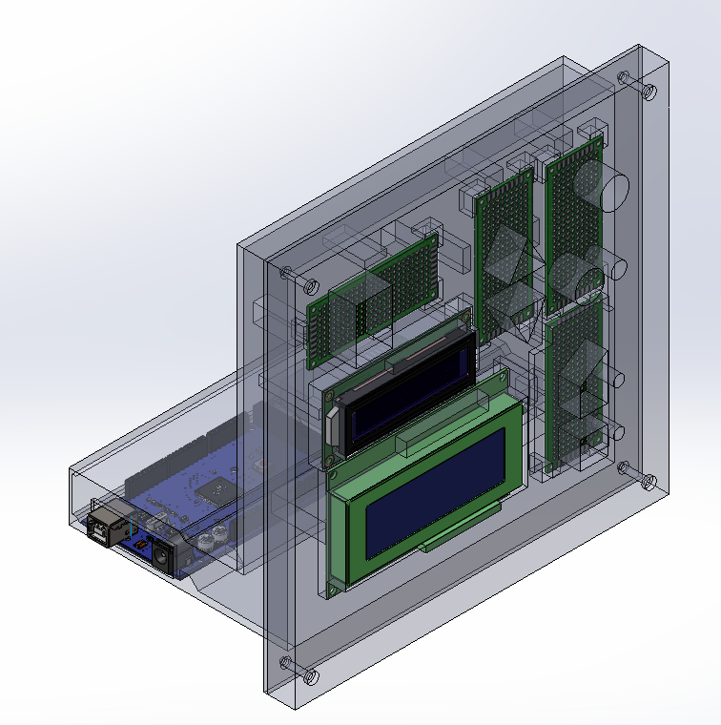
Figure 2 - Full assembly of CAD model for the interface and electrical box

3.2 Symbol Convention
The interface uses standardized symbols to overcome language barriers:
- Power: Standard IEC 60417-5009 symbol (White).
- Start: Right-pointing triangle (Green).
- Recipe Selection: Icons for Fish, Seaweed, and Vegetables (Blue).
- Manual Mode: Hand symbol (Yellow).
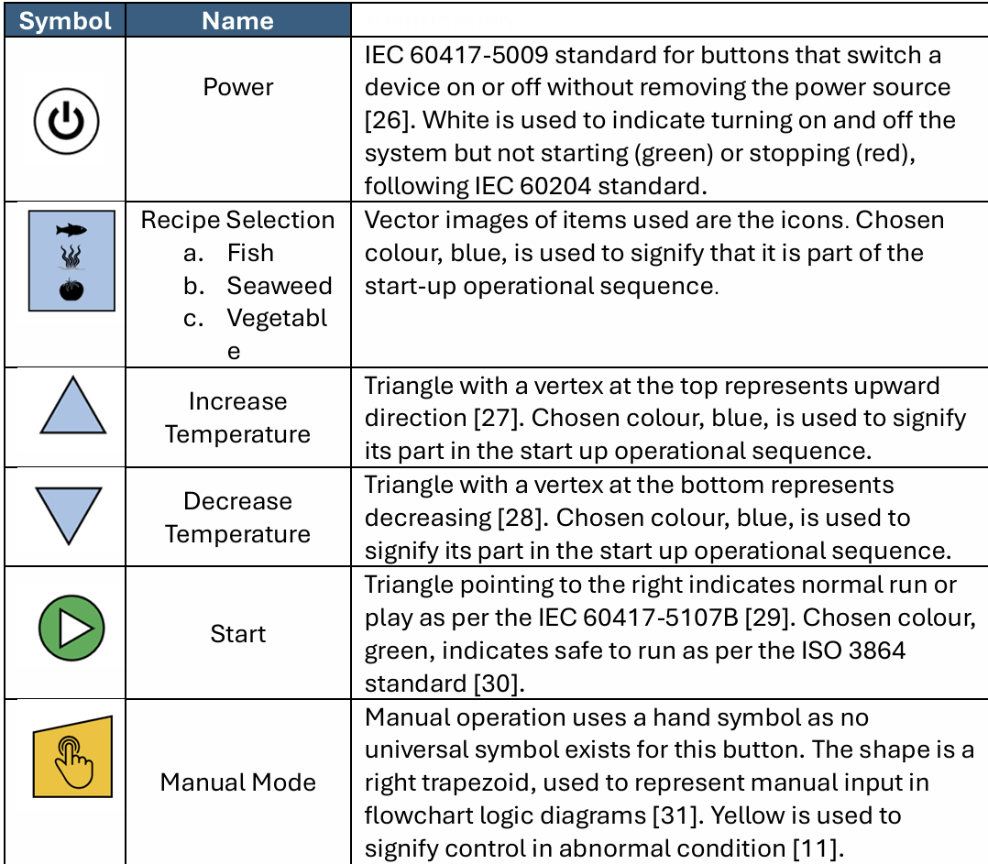

3. Circuitry & Hardware Integration
The system uses discrete control for heaters and exhaust fans. Note: For safety during prototyping, the 220V heaters are tested independently and excluded from the main microcontroller circuit to prevent lethal electrocution risks.
- Fan Control: Connect the fans to the circuit using an N-channel MOSFET and digital potentiometer.
- Thermal Management: Attach a heatsink to the MOSFET. It must have a maximum thermal resistance of to prevent component failure or burns.
- Terminations: Follow Canadian Electrical Code Section 12-116; make all conductor terminations with pressure connectors, solder lugs, or splices.
- Power: Connect to a 24V DC power source for fans and the Arduino power supply.

4. Software Implementation
- Environment: Install Arduino IDE Version 2.3.7 on a compatible computer (Windows 10, Linux, or macOS 10.15+).
- Uploading Code: Upload the provided code to the Arduino MEGA.
- Documentation: Refer to the line-by-line video explanations and heavily commented code to understand logic flow or to make future edits.
- Validation: Use the Serial Monitor to verify that temperature measurements are being recorded and that the MOSFET is responding correctly to the defined temperature deadbands.

5. Safety & Operational Constraints
- Emergency Stop: MAVUNOLAB must install a physical emergency stop that directly disconnects power to both heaters and fans, as the software stop is not sufficient for hardware failures.
- Environment: The entire interface and controller unit must be housed within the existing weather-proof control box to protect against Tanzanian humidity and rain.
- Power Limit: Total system power consumption must remain below 5% of the total available power.

6.Detailed Maintenance Schedule
To ensure the system maintains the target temperature within $\pm5^{\circ}C$ and survives the harsh environment, follow this schedule.
6.1 Weekly Maintenance
- Visual Inspection: Check the 3D-printed interface for any signs of thermal warping or cracking, despite using heat-stable ASA.
- Sensor Cleaning: Wipe temperature and humidity sensors to ensure dust or debris does not cause "noise" that impacts incorrect cycling of fans and heaters.
- Data Retrieval: Download the .csv log files from the SD card to monitor for any performance drift.
6.2 Monthly Maintenance
- Fan Performance Test: Visually verify the fan varies from 0% to 100% speed to ensure the digital potentiometer and MOSFET are functioning correctly.
- Wiring Check: Inspect terminal parts for corrosion or loose connections, ensuring they remain secure under vibration or thermal expansion.
- Heatsink Inspection: Ensure the MOSFET heatsink is free of dust and is still securely attached to prevent overheating.
6.3 Annual Maintenance
- Seal Integrity: Inspect the weather-proof control box gaskets to ensure no moisture is reaching the Arduino or internal circuitry.
- Full System Recalibration: Compare the internal sensor readings against a calibrated handheld thermometer to identify any sensor degradation.
- Code Review: Review the SD card logs for any "Errors in Code" or unexpected resets that may require a firmware update

Code Modification
- Accessing the GitHib Repository

To access the GitHub repository for MAVUNOLAB, start by going to GitHub and logging into your account. In the search bar, type “MAVUNOLAB” and select the correct repository from the results, or use the link provided.
Once on the repository page, you can view files, documentation, and code online, or click the green “Code” button to copy the repository URL. You can then clone it to your computer using a tool like Git by running git clone in your terminal, which downloads the full project so you can work with it locally.
- Download all libraries
To import Arduino libraries, open the IDE and navigate to
Sketch > Include Library > Manage Libraries.
To search for and install a library automatically. If you have a downloaded file, use Sketch > Include Library > Add .ZIP Library... to select it from your computer. These methods correctly link the header files, allowing you to use the #include statement in your code.
For troubleshooting or specific questions on library compatibility, visit the link below:
Arduino Forum - Libraries
- In Temperature setpoint variables
  - Set recipe setpoints and min/max temperatures
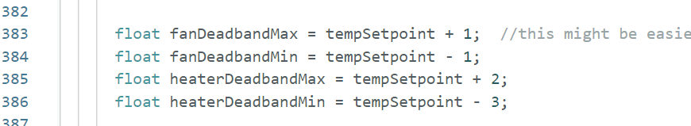
Figure 3 - Code to Modify Temperature Set Points
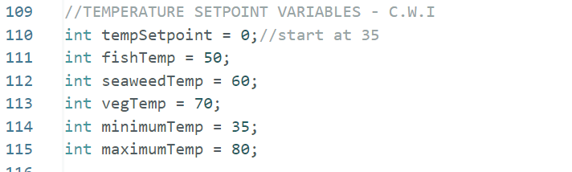
Figure 4 - Code Sample to Modify Recipe Temperatures

MAVUNOLAB Solar Dryer: User Instructions


1. Interface Overview: Buttons & Screens
The control panel uses standardized colors and symbols to make operation simple regardless of language.
- Power (White Icon): Turns the system interface on or off without disconnecting the main power source.
- Recipe Selection (Blue Icons): Chooses the pre-programmed temperature sequence for Fish, Seaweed, or Vegetables.
- Temperature Adjustment (Blue Triangles): The triangle pointing up increases the temperature, and the triangle pointing down decreases it.
- Start (Green Triangle): Initiates the normal drying cycle.
- Manual Mode (Yellow Hand): A trapezoid button that allows you to override normal operation and manually input controls during abnormal conditions.
- LCD Information Screens: The top screen displays your current Temperature Set Point (e.g., 75°). The bottom screen displays the Elapsed Time (e.g., 56:00) and real-time Temperature Measurements inside the dryer.

2. Standard Operating Instructions
Follow these 4 steps to begin a standard drying cycle:
- Power On: Press the white Power symbol button to turn on the interface and system.
- Select a Recipe: Press the blue Recipe Selection button with the vector icons to choose the appropriate drying mode for your crop (Fish, Seaweed, or Vegetables).
- Adjust Temperature (If Needed): Check the top LCD screen to view the default Temperature Set Point for your recipe. If you need it hotter or cooler, press the blue Up or Down Triangles to change the target temperature.
- Start Drying: Press the green Start triangle. You can now monitor the process using the bottom LCD screen, which will show the running Elapsed Time and actual Temperature Measurements.
(Note: If the system enters an abnormal state or you wish to bypass the recipes, press the yellow Manual Mode hand symbol instead of step 2.)
3. Safety & Routine Maintenance
- Emergency Stop: Do not use the white interface power button for emergencies. You must use the physical emergency stop switch to directly disconnect power to the heaters and fans in the event of a hardware failure.
- Weather Protection: Ensure the sliding rear cover is closed and the interface is properly housed in its weather-proof box to protect the electronics from humidity and rain.
- Weekly Upkeep: Once a week, wipe the temperature and humidity sensors clean of dust or debris to ensure the fans and heaters cycle correctly. Inspect the 3D-printed faceplate for any thermal warping or cracking.

MAVUNOLAB DISPOSAL
End-of-Life & System Disposal
Proper disposal of the control system is critical to prevent environmental contamination, especially concerning the electronic components and heavy metals. When the system is damaged beyond repair or reaches the end of its operational lifespan, do not discard it in standard municipal waste or agricultural burn piles.
Step 1: Safe Disconnection
- Ensure the entire dryer system is powered down.
- Completely disconnect the system from the 24V DC power source and the 220V heaters before attempting any disassembly.
Step 2: Disassembly & Sorting
- Slide off the rigid rear cover and unscrew the Arduino MEGA from its specialized mounting bracket.
- Carefully remove all screens, buttons, and wiring from the mounting holes of the 3D-printed faceplate.
- Separate the materials into three distinct categories: E-Waste, Metals, and Plastics.
Step 3: Component-Specific Disposal
- Electronic Waste (E-Waste): The Arduino MEGA, 16x2 LCD screens, N-channel MOSFETs, digital potentiometers, SD card module, and the temperature/humidity sensors contain hazardous materials like lead and silicon. These must be taken to a designated e-waste recycling facility.
- Metals & Wiring: The metal heatsinks and the AWG 22 gauge copper wires can be recycled. If local facilities allow, strip the plastic insulation off the wires to recycle the copper at a scrap metal collection point.
- Plastics: The interface cover, sliding rear cover, and mounting bracket are made from 3D-printed ASA (Acrylonitrile Styrene Acrylate) filament. ASA is a durable thermoplastic; check with local recycling centers to see if they accept Number 7 (Other) industrial plastics. If not, dispose of it in standard solid waste, but never burn it, as it releases toxic fumes.

